

**Parish of St Brélade British Legion Brunch**

**1100-1400**

**Friday 8th November 2024**

**📍St Brélade Parish Hall**

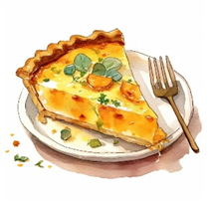

**Join us for a hot drink & a savoury pie & come and support this wonderful community event**

**All donations go directly to this charity**

**Royal British Legion merchandise available on the day**

