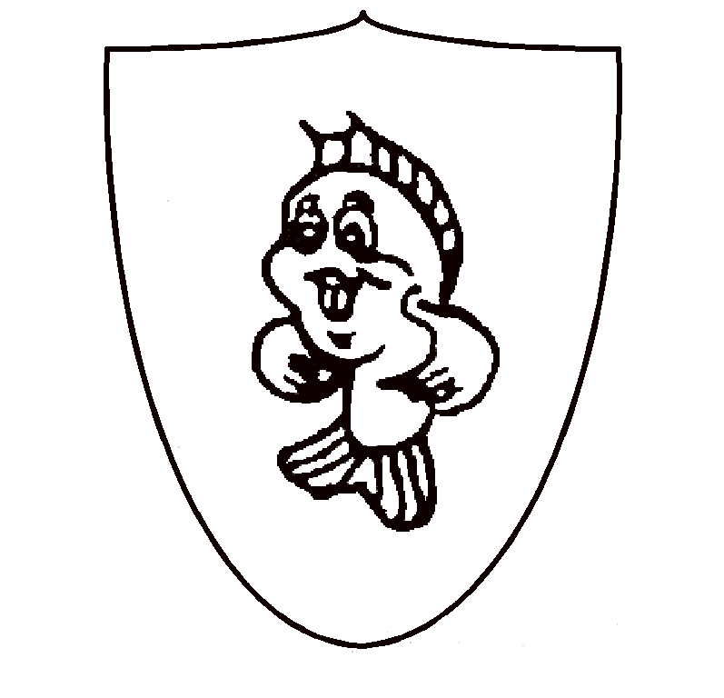
St Brelade Battle of Flowers Association
Imagine * Create* Aspire
March 2022
Dear Parishioners,
Once again we are appealing to parishioners to help with our efforts to build and flower this years float to enter in the Jersey Battle of Flowers parade. After a two year break we are producing one of the largest floats that will be in the Parade this special 120th year of battle.
Each year we ask for help and in the past we have been very fortunate in the replies we’ve received, but with a new year we are hoping that some more people might take an interest in our appeal.
The 2019’s “Land of Na’vi” saw us take the costume award and once again 3rd in the Parish class. This year we are aiming high with something different. The float this year is based on the magic of Disney and will be very colorful, full of detail and fun.
As well as the float we are in the very fortunate situation that we own the shed where we build our float. However, this does come with the additional expense required for its maintenance. Following my last letter, I am pleased to report that work on the roof and gutters have been finished. We have also been able to ensure more maintenance has been completed ahead of schedule and a reorganization of the shed has been started. During 2022 our attention will mainly be focused on upgrading the electrics.
We are a small and friendly team and without your help we would not be able to continue. If you feel that you have some spare time and would like to get involved with the Association, don’t hesitate to get in contact with us and join our Facebook page for the latest news. The shed is open Tuesday and Wednesday 10-1, Thursday 7-9 and Saturdays 10-2 from mid-March.
A bit more information on the area where you can help.
Building
This years build is well underway but as ever we could always do with extra help for the last push. The building of the float includes small as well as big build projects as well as covering, painting and also lining the float ready for the flowering.
Dry work
This is mainly harestailling, but can also include beaning and seeding. It can be very awarding to complete a piece of detailed work and can go on to win an award. It is these detailed pieces that really make the float come alive.
Costume
We have two lovely ladies who have offered to make some of the costumes needed this year but as ever, many hands make light work so if you would like to join this growing team we would love to hear from you.
Fundraising We are looking for somebody to organize our fundraising events. This can be from a raffle right through to a fete. We have a small, but dedicated team who will always be on hand to provide assistance. If you feel that you have the skills required then please do get in contact.
Juniors
2022 is the year that we are all coming together to produce a float with as many people involved as possible. We would like to introduce new, younger members to the team and with 2023 in mind; we would like to introduce a junior float back to St Brelade. During this year we would like anybody who would like to be involved to come forward and help out at every step of the way. From harestailing, flowering, dancing and of course the build. If you are or have children aged 18 years or younger then please do get in contact. We do need your support in this to enable us to grow the team in 2023.
With all that in mind the shed is open Tuesday and Wednesday 10-1, Thursday 7-9 and Saturdays 10-2 from mid-March. If you would like to contact us outside of these times then please text (“Battle help”, followed by your name and area which you would like further information on) to the Chairman on 07797837846 and somebody from the Committee will be in contact. Alternatively you can email dcavrill@yahoo.co.uk.
Dates for your diaries
Wednesday 3rd August. Time T.B.C. We need as many people as possible as we will have arriving 36,500 steams which will need stripping and putting in water.
Monday 8th August – Wednesday 9th August. Flowing of the float, we will need pickers, gluers and people to flower the float. This really is an exciting time to be involved in the final stages of completing the float.
Thursday 11th and Friday 12th August. Battle parades.
May I take this opportunity of thanking you in advance for your new and continuing support.
Yours sincerely
Daniel Avrill (Chairman of St Brelade Battle of Flowers Association)
I enclose a donation of £……………………………………….
If a receipt is required please complete this section below to enable us to send a reply.
Name…………………………………………
Address…………………………………………………………………………………………………………………………………………………………………………………………..
Cheques can be made payable to St Brelade Battle of Flowers Association and return to St Brelade Battle of Flowers shed, La Rue Carre, St Brelade, JE3 8FJ. (Next to Parish Depot). Cash donations can be left in our secure letterbox, please do not send cash through the post. If you would like to make a digital transaction our account number is 91052500 and sort code 40-25-41.
Please complete if you would like to receive a newsletter from us via email.
Email………………………………………………………………………………………….

