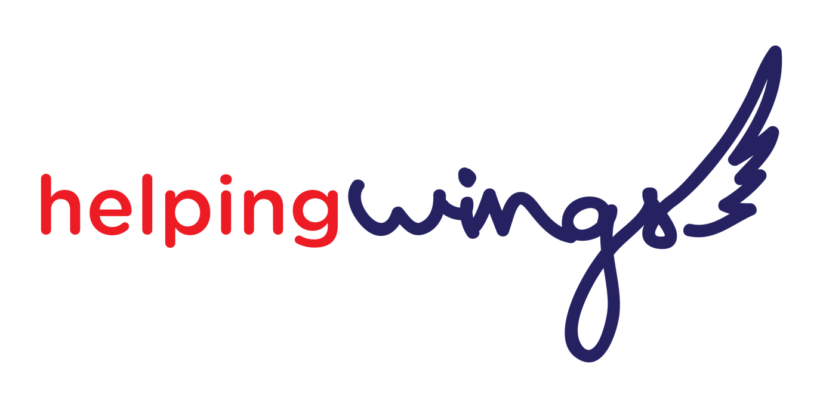

**Jersey’s Flying Charity**

**2022 Flying bursary sponsored by Ports of Jersey**

Helping Wings, the Jersey light aviation charity, is delighted to announce the 2022 bursary worth £2000 of flying training sponsored by Ports of Jersey with Synergy Flight Training based at the Jersey Aero Club.

The first step is filling in this form, after which we will invite the applicants to come and meet us so that we can find out more about them and let them know more about the flying training.

To apply for the bursary, the applicant must be over 16 years old and be willing to share the flying experience on social media to help us raise the profile of the bursary.

There is no medical examination for the bursaey. We may seek a medical opinion to ensure that both the successful candidate and the instructors can complete the bursary safely. However, to date we have been able to welcome students with a variety of disabilities so please consider applying. If you have any concerns about your fitness to fly, you are welcome to contact us for a discussion before applying.

We will not share the information on this form beyond the selection panel without your consent. We will only retain the application form from the successful applicant whose details will be shared with Synergy Flight Training instructors.

**APPLICATION FORM FOR THE 2022 FLYING BURSARY**

**Name -**

**Date of birth -**

**Address -**

**Contact telephone number -**

**Email -**

**Occupation -**

**Have you lived in Jersey for over 5 years? -**

**Interests; Hobbies; Sport participation -**

**Have you ever flown in a light aircraft -**

As some of the applicants may be physically disabled, we need to understand the nature of the disability so that we can ensure that the training is completed in a safe and enjoyable environment.

To help us with this, please describe below any disability or other challenge you may be experiencing and the impact this has on your everyday life.

Please ask 2 people you know well, who are not close family members, to support your application as referees. We may contact them on receipt of your application.

**REFEREE 1**

Name -

Address -   
  
  
Email -

Telephone number -

**REFEREE 2**

Name -

Address -

Email -

Telephone number -

I wish to apply for the 2022 Helping Wings bursary. I have read the notes and accept the condition on this form. I understand that all flying training **must** be completed within a year.

Name -

Signature - Date -

Parents/Guardian name and signature required if under 18 years of age.

Please return this form as well as the medical self-declaration form fully completed to [**hello@helpingwingsjersey.org**](mailto:hello@helpingwingsjersey.org)

