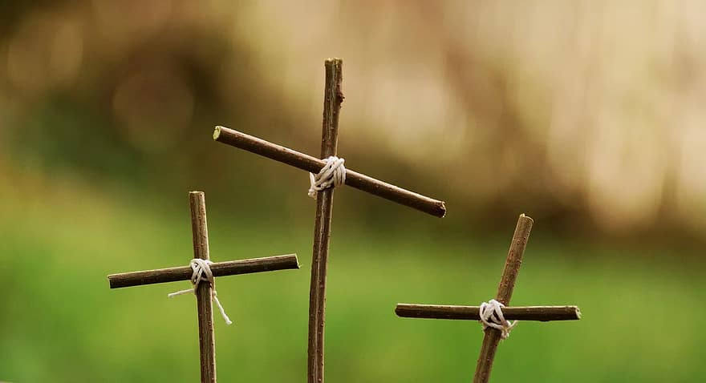
Holy Week & Easter Services

Palm Sunday Service - Sunday 29th March
08:00am Holy Communion (BCP)
09:15am Holy Communion Service - St Aubin on the Hill
10:30am Parish Communion Service

Maundy Thursday Service – Thursday 2nd April
18:30 pm Parish Church Service

Good Friday Services – Friday 3rd April
10:00am Stations of the Cross - St Aubin on the Hill
2:00 – 3:00pm An hour at the Cross

Easter Sunday – Sunday 5th April
06:00 am Dawn Bonfire in Rectory Field
followed by First Light Communion in the Fisherman’s Chapel (Bacon Rolls in the Hall after service)
08:00 am Holy Communion (BCP)
09:15 am Holy Communion Service-St Aubin on the Hill
10:30 am Parish Communion Service

The Parish Church of St Brelade with St Aubin on the Hill

www.stbreladeschurch.com 

